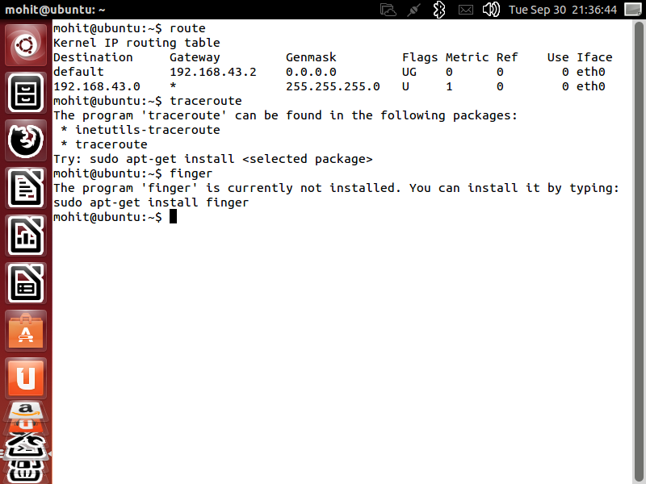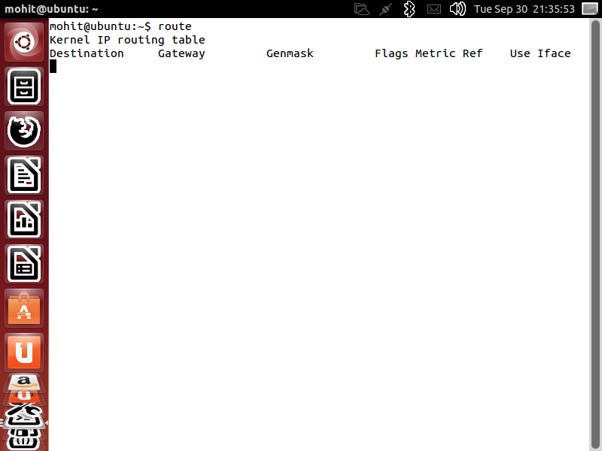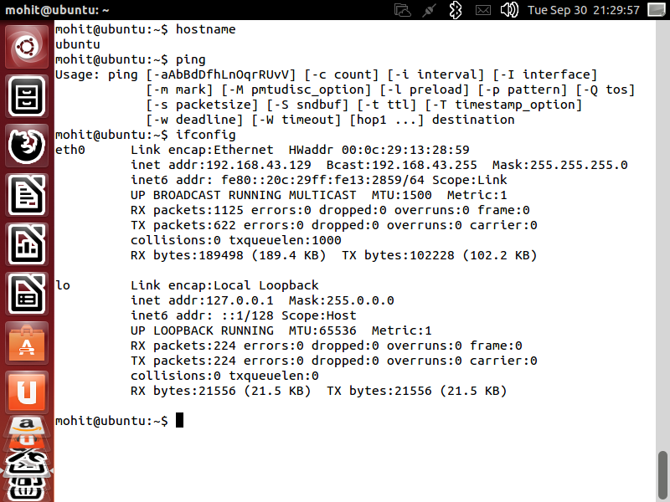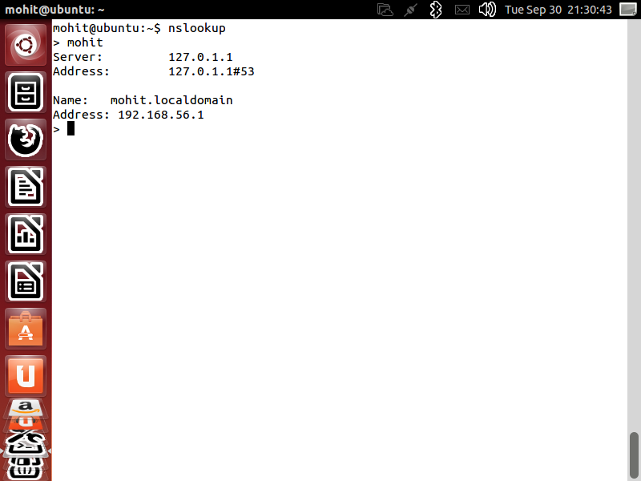

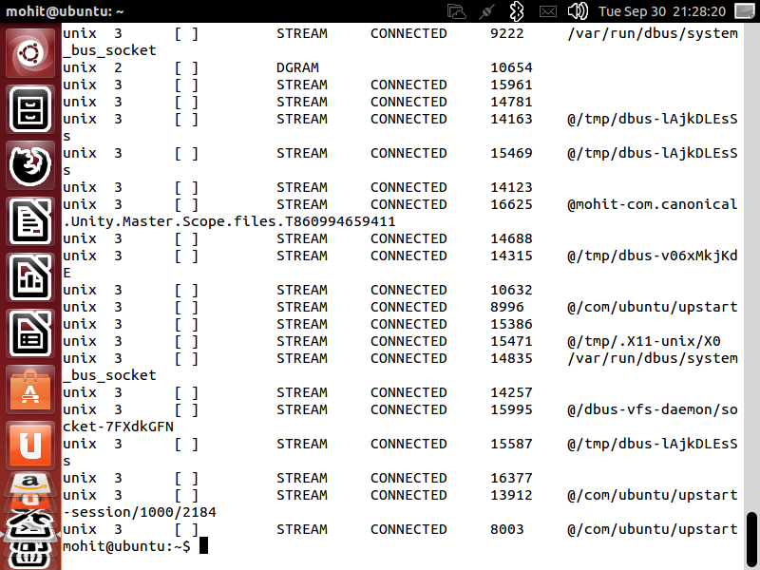

***Experiment No.3***

***A.i.M - :*** Implement a Hamming Code in c.

Source Code -:

#include<stdio.h>

void main() {

int data[7],rec[7],i,c1,c2,c3,c;

printf("this works for message of 4bits in size \nenter message bit one by one: ");

scanf("%d%d%d%d",&data[0],&data[1],&data[2],&data[4]);

data[6]=data[0]^data[2]^data[4];

data[5]=data[0]^data[1]^data[4];

data[3]=data[0]^data[1]^data[2];

printf("\nthe encoded bits are given below: \n");

for (i=0;i<7;i++) {

printf("%d ",data[i]);

}

printf("\nenter the received data bits one by one: ");

for (i=0;i<7;i++) {

scanf("%d",&rec[i]);

}

c1=rec[6]^rec[4]^rec[2]^rec[0];

c2=rec[5]^rec[4]^rec[1]^rec[0];

c3=rec[3]^rec[2]^rec[1]^rec[0];

c=c3*4+c2*2+c1 ;

if(c==0) {

printf("\ncongratulations there is no error: ");

} else {

printf("\nerron on the postion: %d\nthe correct message is \n",c);

if(rec[7-c]==0)

rec[7-c]=1; else

rec[7-c]=0;

for (i=0;i<7;i++) {

printf("%d ",rec[i]);

}

}

}

***Output-:***

